Report title: report subtitle as needed
(two lines long in 22 point arial)

First Author¹, Second Author², 12 point arial
- First Author Affiliation
- Second Author Affiliation



Inquiries should be addressed to:
[Contact Name]
[Organisation/Affiliation]
[Contact email]
This report should be cited as
Surname IN, Surname IN, Surname IN (YEAR) Report title: report subtitle. A report to the Australian Government by the COTS Control Innovation Program (XX pp).
Funding Acknowledgement
The COTS Control Innovation Program aims to accelerate the development of innovative surveillance and control methods to manage outbreaks of coral-eating starfish on the Great Barrier Reef. The Program is a collaboration between the Great Barrier Reef Foundation, Australian Institute of Marine Science, Commonwealth Scientific and Industrial Research Organisation, James Cook University and The University of Queensland. This project is part of CCIP’s Bridging Phase which is funded by Australian Government’s Reef Trust, the Australian Institute of Marine Science, and the Great Barrier Reef Foundation.
Traditional Owner Acknowledgement

The COTS Control Innovation Program extends its deepest respect and recognition to all Traditional Owners of the Great Barrier Reef and its Catchments, as First Nations Peoples holding the hopes, dreams, traditions and cultures of the Reef.
Disclaimer
While reasonable efforts have been made to ensure that the contents of this document are factually correct, CCIP does not make any representation or give any warranty regarding the accuracy, completeness, currency or suitability for any particular purpose of the information or statements contained in this document. The views and opinions expressed in this publication are those of the authors and do not necessarily reflect those of the Australian Government.
Copyright
© Copyright: XXXX.

Contents
Automatic Generation of Table of Contents
- using Heading 1, Heading 2 and Heading 3 styles will allow your table of contents to generate automatically
- To update the Table of contents, Right click on table of contents and click ‘Update Field’ then select the options of “Update entire table”

Project Summary 1
Context & Objectives 1
Methods 1
Results 2
Disucssion & Outputs 2
Outcomes & Impact Pathway 3
Conclusions & Next Steps 3
Acknowledgements 3
Data Accessibility 3
References 4
Formatting and style guide 5
Using template styles 5
Page layout and numbering 5
Figures, tables and equations 6
Captions for figures and tables 6
Equation formatting 6
Style examples 7
This is the Heading 2 style 7
This is the Heading 3 style 7
Body Text 7
Numbered List 7
Appendix A – [title] 8
Appendix B – [title] 9

Table of Contents for captions, figures and tables
Use the Caption feature to label figures, tables and other items in order to generate a table of contents for these items.
Access the Caption feature via the References ribbon, Insert Caption. Customise the label by adding additional text relevant to your item. This feature will automatically use the Caption style for formatting.

List of Figures

Figure 1 Example caption for Figures, use the insert Caption feature in the ‘References’ tab 5

List of Tables

Table 1: Headings for Tables using the Caption Style 5

Acronyms and Abbreviations

COTS | Crown-of-thorns starfish
CCIP | Crown-of-thorns starfish Control Innovation Program
Reef Authority | Great Barrier Reef Marine Park Authority

Project Summary
Briefly summarise each section of the report with a focus on highlighting the key results and their benefits for people and the environment. Include headline figures / stats that will help to illustrate the impact of your research to a broad audience. Keep the summary concise and avoid technical jargon.
Length guidance: 1 page maximum.

Context & Objectives
In this section provide the necessary background context for the bridging project and describe the challenge and/or knowledge gap(s) that the project addresses. Reference any previous CCIP projects that this bridging project builds upon. Briefly review and cite key literature.
Use subheadings as needed and refer to Formatting and Style Guide.
State which priority research area (or areas) the project contributes to, as set out in the project workplan.
This section must conclude with a dot point list of the specific project objectives:
- objective 1
- objective 2, etc
Length guidance: 2-3 pages.

Methods
In this section provide the details of the methodology used to address the stated objectives, including those related to sampling design, data collection, training protocols, technology/tool development, laboratory protocols, field sampling/experimentation, and statistical analyses.
Include details of ethics approvals and permits where applicable.
Use 1-3 key figures and/or photographs to illustrate your methods. For field-based projects this should include a map of fieldwork locations / sampling sites.
This section must include a dedicated subheading ‘Engagement with Rights-holders and Management Stakeholders’ that describes engagement activities that were delivered as part of the project to achieve its objectives. This should include outlining activities under the project’s Indigenous Engagement Plan and engagement the COTS Control Program (i.e. managers and/or control vessel crews).
Length guidance: 2-3 pages text (plus 1-3 key figures). Further details and supplementary information can be provided as Appendices.

Results
Describe the project’s findings in this section including the results of any statistical analyses, case studies or technology/model development.
Use subheadings to organise and highlight key results.
Include 2-4 key figures, tables and images to illustrate results in this section (further supplementary information such as figures, tables, code can be included in Appendices). Insert each figure and table directly after the paragraph in which it is first cited (read order).
Length guidance: 3-4 pages text (plus 2-4 key figures). Further details and supplementary information can be provided as Appendices.

Disucssion & Outputs
Discuss the interpretation of the results presented in the previous section, placing them in broader context with related research / contributions in the field. Cite key literature.
Include commentary on any limitations or key assumptions underpinning interpretation and any results that defied expectations.
This section must conclude with a dot point list of the final outputs of the project (as per the project workplan/ workshop output register):
- Output description 1
- Output description 2
- Output description 3
Length guidance: 3-4 pages.

Outcomes & Impact Pathway
State which CCIP Program Outcomes this project’s outputs contribute to, as set out in the project workplan and the workshop synthesis document (mapping exercise).
Describe how the research enables increased capacity, efficiency or effectiveness through the application of new knowledge, methods, tools or technologies by COTS control managers/crews, Traditional Owner rights-holders and/or any other stakeholders (including other researchers).
Refer back to the engagement subheading in the Methods to emphasise collaboration and consultation that was undertaken to support the pathway to impact for the research.
Highlight any key next steps for stakeholders and rights-holders that may be needed to use and achieve the intended outcomes and impact.
Length guidance: 1-2 pages text (figures optional).

Conclusions & Next Steps
Highlight any further research that is needed to advance or build upon the project’s outputs and outcomes (if applicable).
Conclude the report by summarising the key findings and highlighting the most significant change that this bridging project has enabled.
Length guidance: 300 words.

Acknowledgements
Acknowledgements for those people or organisations that contributed to the project but are not co-authors.
This can also be used to acknowledge additional sources of funding or in-kind contributions above and beyond those listed in the standard CCIP funding acknowledgement at the start of the report.

Data Accessibility
This section should state where project data are stored, such as a public or institutional repository and must include a link to access the data in line with FAIR data principles.
In addition to this requirement, data should also be registered in relevant data information systems (e.g. COTS Information System) to support its access and use amongst other COTS researchers and managers.
In cases where there are sensitivities in making data open (e.g. personal information protected under human research ethics permits) authors should provide a statement explaining these circumstances here.

References
Format references and in-text citations using the style from the journal Coral Reefs.
Reference list entries should be alphabetized by the last names of the first author of each work according to the following rules: 1) For one author, by name of author, then chronologically; 2) For two authors, by name of author, then name of coauthor, then chronologically; 3) For more than two authors, by name of first author, then chronologically.
If available, please include DOIs as full DOI links in your reference list (e.g. “https://doi.org/abc”).
Examples of in-text citations:
- Negotiation research spans many disciplines (Thompson 1990).
- This result was later contradicted by Becker and Seligman (1996).
- This effect has been widely studied (Abbott 1991; Barakat et al. 1995a, b; Kelso and Smith 1998; Medvec et al. 1999, 2000).

Journal article example:
Gamelin FX, Baquet G, Berthoin S, Thevenet D, Nourry C, Nottin S, Bosquet L (2009) Effect of high intensity intermittent training on heart rate variability in prepubescent children. Eur J Appl Physiol 105:731-738. https://doi.org/10.1007/s00421-008-0955-8
Book chapter example:
Brown B, Aaron M (2001) The politics of nature. In: Smith J (ed) The rise of modern genomics, 3rd edn. Wiley, New York, pp 230-257

Online document example:
Cartwright J (2007) Big stars have weather too. IOP Publishing PhysicsWeb. http://physicsweb.org/articles/news/11/6/16/1. Accessed 26 June 2007

Formatting and style guide
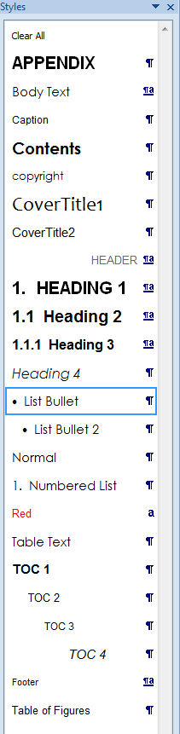
Use this section as a quick reference for applying the template styles and keeping the report layout consistent. Applying the built-in styles helps the table of contents, list of figures and list of tables update correctly.

Using template styles
- Apply the template styles for headings, body text, tables, captions, bullet points and numbered lists rather than manually formatting text. This keeps the report consistent and reduces formatting issues when content is updated or converted to PDF.
- Use Arial throughout the report. Body text should use the template body text style at 11 point.
- If you cannot see the required style, open the Styles pane from the Home tab and select the appropriate style from the full list.
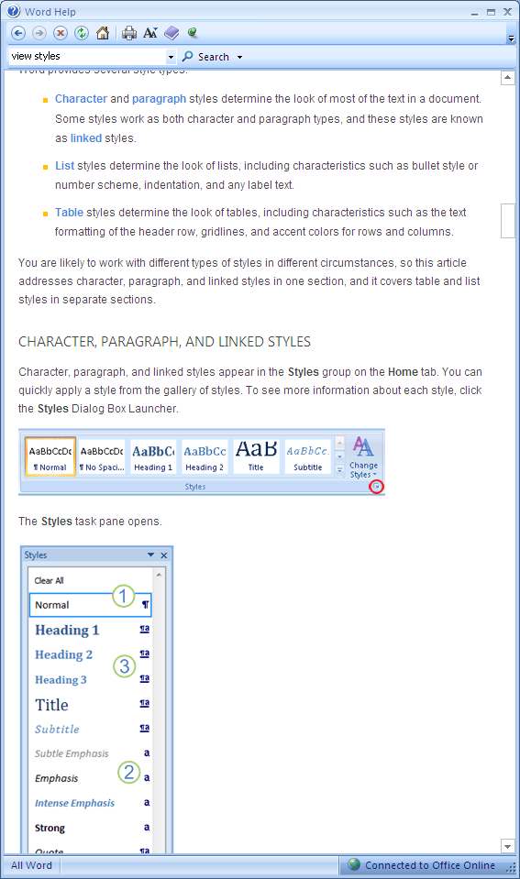
- Use Heading 1 for main report sections, Heading 2 for major subsections and Heading 3 for supporting subsections.
Styles panel
- Use the template body text style for standard paragraphs.
- Use the template bullet and numbered list styles for lists. Restart or continue numbering using the right-click numbering options if needed.
- Use Enter for a new paragraph and Shift + Enter only when you need a line break within the same paragraph.
- Use Clear All Formatting or Normal style to remove unwanted pasted formatting, then reapply the correct template style.

Page layout and numbering
The template is set up for A4 pages with standard margins, section breaks, headers, footers and automatic page numbering. Keep these settings unless a specific table, figure or map needs a different layout.
- To insert a manual page break, go to Layout > Breaks > Page.
- To create landscape pages within a portrait document, first select the text or content that needs to appear in landscape, then go to Layout and choose Orientation > Landscape. Word will automatically insert the required section breaks before and after the selected content.

Figures, tables and equations
Insert figures, tables and other visual material close to where they are first cited in the text (in read order). Keep all visual elements within the page margins and use the template styles for captions and table text so numbering, lists and formatting remain consistent.
If an image, graphic or other pasted object does not display correctly, first check the paragraph style, size and layout settings. Applying Normal style, using Clear All Formatting, or adjusting the picture layout will resolve most issues caused by pasted content. For text wrapping, use a simple option such as In line with text or Top and Bottom unless another layout is required.

Captions for figures and tables
Use Insert Caption for every figure and table. Go to the References tab, select Insert Caption, choose Figure or Table, and add the caption text after the automatic number. This keeps numbering automatic and allows the List of Figures and List of Tables to update correctly.

Use the template table text style for table content and keep tables within the page margins where possible.

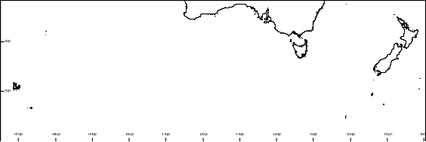
Figure example
Kerguelen Islands
3900km
Heard and McDonald Islands
1500km
Macquarie Island
Figure 1 Example caption for Figures, use the insert Caption feature in the ‘References’ tab

Table example
Table 1: Headings for Tables using the Caption Style
Sample Table Layout | Sample | Sample | Sample
Table Text Sample | 4 | 5 | 6
Table Text Sample | 7 | 8 | 9

Equation formatting
Use borderless tables to position equations and equation numbers consistently. Create a blank equation row that can be copied and reused elsewhere in the report.
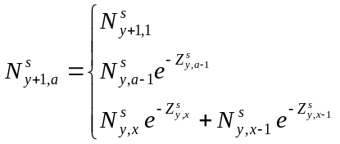 |  | (5.A.1)

Style examples

This is the Heading 2 style

This is the Heading 3 style

This is the Heading 4 style

Body Text
This is the body text
- This is a bulleted list
- Bullet 2
- Bullet 3

Numbered List
- This is a Numbered List.
- Numbered List. To restart numbering, right-click the number and select Restart Numbering
- Numbered List. To continue numbering, right-click the number and select Continue Numbering

Appendix A – [title]

Appendix B – [title]

<Insert Name, title, email of key contact for this report here>

